

Using Google Docs

Rachel Egnor, Virginia Tech 2020

2

How to Use Google Docs:

Created By: Rachel Egnor, Virginia Tech 2020

Table Of Contents:

Helpful Tools To Get You

Started​………………………..………………………………………………3

Why You Should Use Google Docs​…………………………………………………………………….3

Opening A Google Account​………..…………………………………………………………………….4

Step 1: Opening The Program​…………………………………………………………………………..8

Step 2: Naming Your Document​………………………………………………………………………...9

Step 3: Add Collaborators to Document​………………………………………………………………10

Method 1: Email

Method 2: Get Link

Step 4: Choosing What Your Text Looks

Like​……………………….……………………………….12

Step 5: Choosing Line Spacing​.……………………………………………………………………….13

Step 6: Inserting Images​……………….……………………………………………………………….11

Step 7: Adding Headers/Footers​...………………………………………..…………………………..14

Step 8: Editing You

Document​...……………………………………………………………………….17

3

Helpful Tools to get you started: Keyboard Commands! Press and hold the button with the letters “Ctrl” or “Control” on your keyboard (typically you have two of these buttons: one in the bottom left, and one on the bottom row two keys away from the space bar) you can use either one, but you don’t need both!) then press another key at the same time. (Just press Ctrl and that key, no other keys, or your command might not work)

Ctrl + A = Highlights all the text, allowing you to manipulate all of your text at once.

Ctrl + F = Opens a box that allows you to type a word, phrase, or characters you want to find in your document and finds all instances for you.

Ctrl + X = If you have text highlighted, you can use this command to “cut” the text. This will remove the text from where it is right now, but lets you use another keyboard command to put it somewhere else later. (Ctrl + V, we’ll get to it!)

Ctrl + C = If you have text highlighted, you can use this command to “copy” the text. When you use the command, nothing will change on your document. However, when you use other keyboard commands (Ctrl + V, almost there) You can put a copy of the text somewhere else.

Ctrl + V = The paste command. This will take text or pictures that you’ve used Ctrl + V or Ctrl + C on, and will put it where the blinking line cursor is on your document.

What is Google Docs?:

Google Docs is a web-based text editing software. It saves all your documents to Google Drive, but you can access your documents without needing to use Google Drive directly. Google Docs allows you to add other people who can either read, comment on, or edit your document.

Why You Should Use Google Docs:

Google Docs is a great way to collaborate on a project, as it saves changes automatically to the Cloud, so there is no loss of information. You can see everyone who edits the document, look at their changes, and give them different permissions based on what you need them to do. Google Docs allows for users to work on the same document simultaneously, so different parts of the same project can be consolidated without having to go through the hassle of everyone sharing files and then checking each others’ work. Additionally, the doc doesn’t need to be exported to a different file format to give it to someone else. Rather, you can simply add that person as a View Only collaborator and they will have full access to read your document without making changes. This makes work flow easier and faster, making both writing and reading projects simple. Through using Google Docs, you will not only develop a greater understanding of text processors, but also have a great tool to develop team learning.

4

Before You Start, Making A Google Account

Start by typing docs.google.com into your address bar (pictured below).

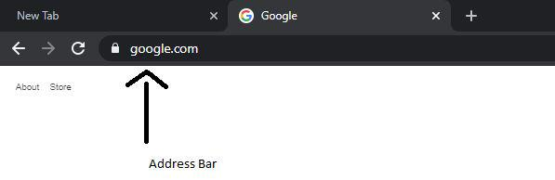

(The Address Bar)

If the following Sign In image doesn’t show up, then that means you are already signed in and can skip to 1. Opening Your Document. Otherwise, click Create Account and For Myself as pictured.

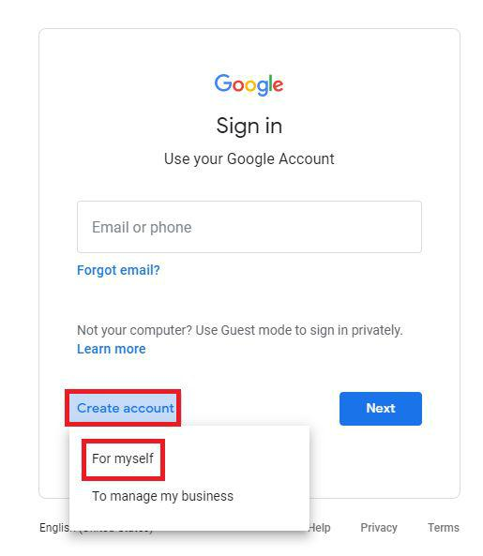

(The Sign In)

Next, a page titled Create your Google Account will show up. Where two boxes say First name and Last name, type your first and last name into them. Then, make up a name you want to use in the Username box. I recommend using the following pattern. The first letter of your first name, following by your last name, followed by the last two digits of your birth year.

Ex. First Last, born 1999 = flast99

5

After creating your email username, create your password. Use capital letters, lowercase letters, numbers, and special characters like “!@#$%” all together to make your password more secure. Type the password your made in the Password box exactly the same way into the Confirm box to make sure you typed it correctly. Then click Next.

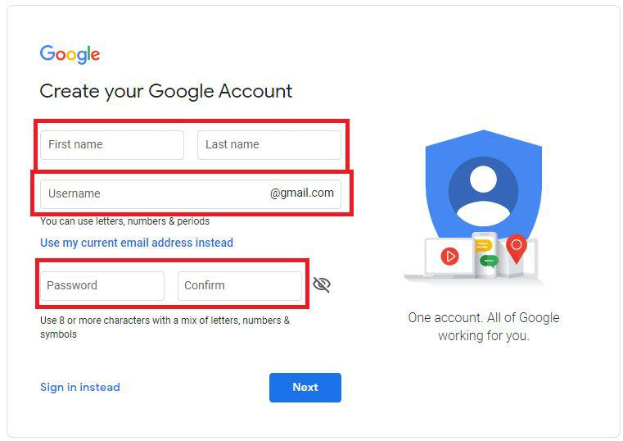

(Name, Username, and Password)

Next, Google requires you to input your Birthday and Gender. This is straightforward, put the month you were born in the Month box, type the day you were born in the Day box, and type the year you were born in the year box.

For Gender, click on Gender and then click the option that applies to you. Then Click Next.

6

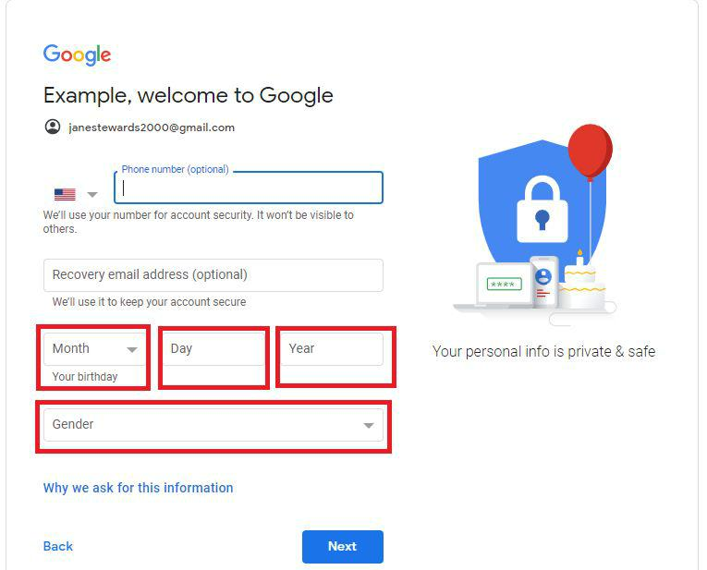

(Date of Birth and Gender)

Next, a page titled Privacy and Terms will show up. Read everything on this page, then click I Agree at the bottom to finish creating your Google Account.

7

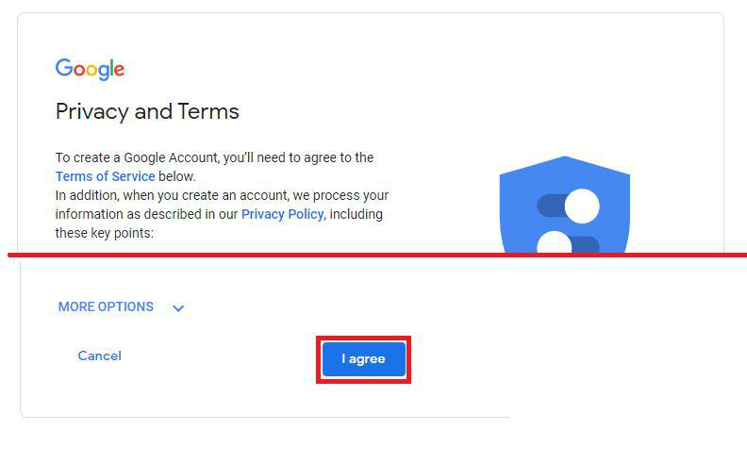

(Privacy and Terms of Service)

8

1. Opening Your Document

Step 1. Open Google Docs. Type docs.google.com into your address bar (shown previously) and then click the colorful plus sign titled Blank.

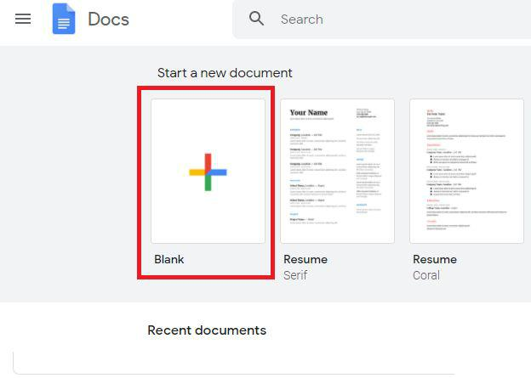

(Figure 1, Google Docs Home Page)

9

2. Naming Your Document

Step 2. Name your document by clicking on the Untitled document text and typing your title. This will make it much easier to find your document later, and will be the name people see when you share the file with someone.

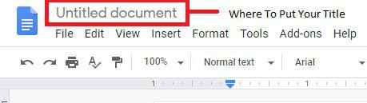

.

(Figure 2, Your Title)

10

3. Add Collaborators to Document

Step 3. Add collaborators. If you want to add other people to work on your document, you can do this by clicking the share button. After clicking the share button, there are multiple options for sharing

Method 1: Email sharing.

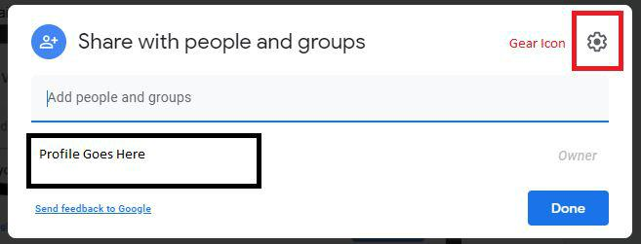

(Figure 3, Sharing By Email)

You can use the top box labelled Share with people and groups (Fig. 3) to enter the gmail accounts of anyone you want to collaborate with. If you want to change what they’re allowed to do on your document, for instance you only want that person to read and not write, then do the following. When you add their email address, click on the highlighted box below, and click Viewer if you want them to only read your document, Commenter if you want them to comment on your document but not edit it, or Editor if you want them to write and delete the document at their discretion.

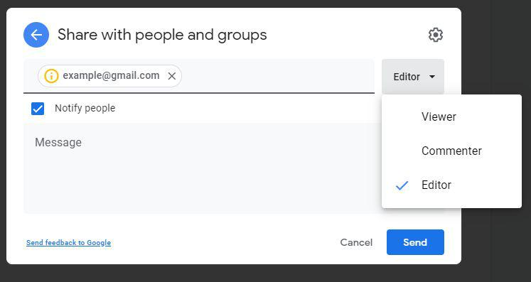

11

(Sharing By Email Permissions)

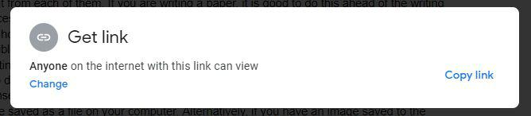

(Figure 4, Sharing By Link)

Method 2: If your collaborators do not have gmail, you can create a link by using the Get Link box (Fig. 4). Note that the link by default will prevent anyone from commenting on or editing your document, so if you want to add additional writers or reviewers, you will have to change permissions by clicking Change, and then choosing the most appropriate role for your collaborator. A Viewer can only see and print your document. A Reviewer can leave comments but can’t add or remove anything directly. A Editor has all the same abilities you do, adding and deleting text directly to the document.

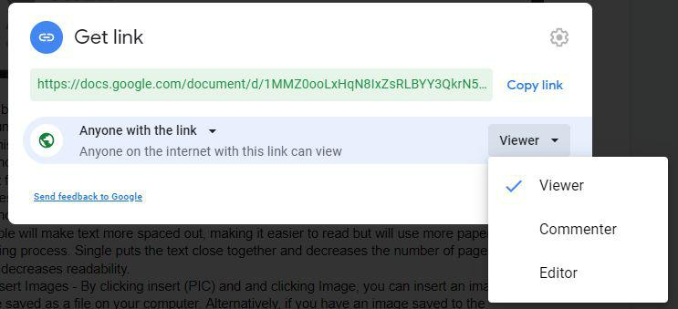

(Figure 5, Sharing By Link Permissions)

12

4. Choosing What Your Text Looks Like

Step 4. Choose Text Font(blue box), Size(red box), and Color(black box). Click on the highlighted boxes(Fig. 6) and choose the option you want from each of them. If you are writing a paper, it is good to do this ahead of the writing process since the size and font of text will affect the page count.



(Figure 6, Text Font, Text Size, and Text Color)

13

5. Choosing The Amount Of Space Between Lines Of Text

Step 5. Choosing Line Spacing - Go to Format, click Line Spacing(Fig. 7), and choose the desired spacing. Double will make text more spaced out, making it easier to read but will use more paper in the printing process. Single puts the text close together and decreases the number of pages, but also decreases readability.

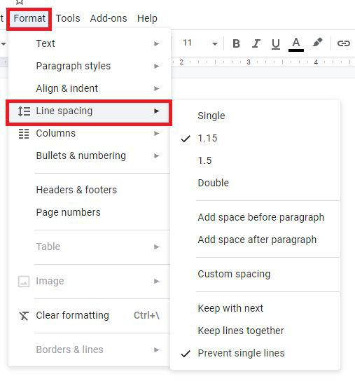

(Figure 7, Line Spacing)

14

6. Inserting Images

Step 6. Insert Images - By clicking insert and and clicking Image(Fig. 8), you can insert an image you have saved as a file on your computer. Alternatively, if you have an image saved using the Helpful Tools keyboard commands, you may use Edit->Paste or Ctrl+V(Fig. 9).

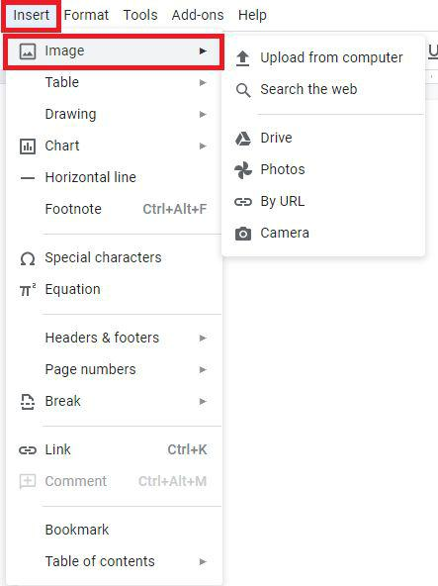

(Figure 8, Putting Image on Your Document)

15

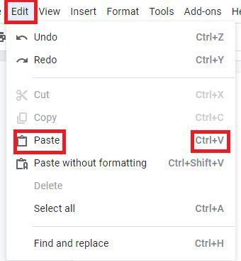

(Figure 9, Pasting)

16

7. Adding Headers/Footers

Step 7. Adding Headers/Footers. A Header is a bit of text at the top of every page of a document. It can contain page numbers, a logo, or contact information you want listed on every page. Footers do the same thing, showing information on every page, but do so at the bottom of the page. Go to Insert, click Headers & footers, and insert a header or footer as desired. After this, double click the top or bottom of a page to enter the header/footer and edit.

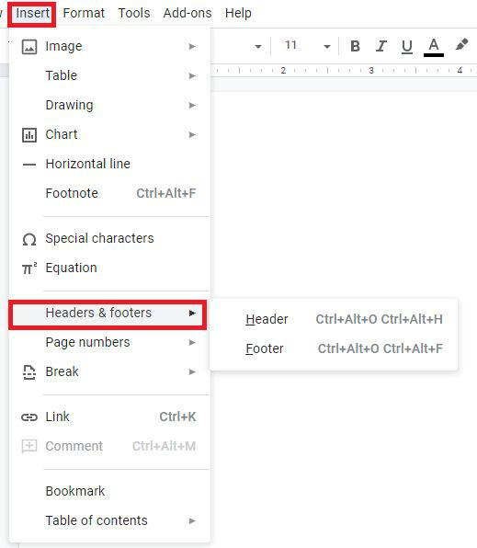

(Figure 10, Inserting Headers/Footers)

17

8. Editing Your Document

Step 8. Edit your document. After writing, you may want to go back and change things. Luckily, Google Documents has some helpful tools to do just that.

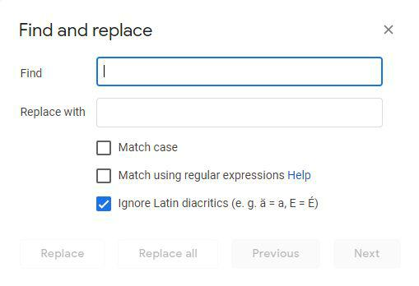

(Figure 11, Find and Replace)

Remembering the keyboard commands from the Helpful Tools, there are some more tools that are a bit more complicated. Ctrl + H will open up a form and allow you to find words, and replace them, similar to Ctrl + F, but with the ability to change the words you want to find.(Fig. 11).

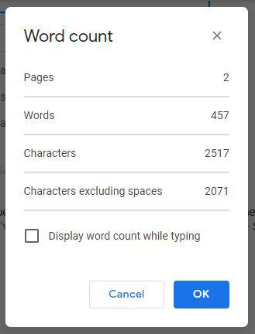

18

(Figure 12, Page Count, Word Count, and Character Count)

If you need to check how many words you’ve written, just use the keyboard command Ctrl + Shift + C(Fig. 12).